**Manual of Compact Models for PMA-MTJ Based**

**On Spin-Orbit and Spin-Transfer Torques**

**SPINLIB: Model PMA_SOT_STT**

**Version: PM_Beta_1.2(2020.05.27)**

Z.H. Wang, Y.S. Xu, W.S. Zhao

Fert Beijing Institute, BDBC and School of Electronic and Information Engineering,

Beihang University, Beijing 100191, China

Contact: [weisheng.zhao@buaa.edu.cn](mailto:weisheng.zhao@buaa.edu.cn)

***Table of contents***

I. General Introduction

II. Files Provided

III. Parameters

III-A CDF

III-B Technology Parameters

III-C Device Parameters

IV. Function Option

IV-A Process variation

IV-B Asymmetry of the STT

IV-C Field-like Torque

IV-D The external magnetic field

V. Before simulation

VI. Other guide

VII. Reference

**·Release note**

|  |  |  |  |  |
| --- | --- | --- | --- | --- |
| Revision No. | History | Draft Date | Editor | Description |
| 1.0 | First release | —— | Zhaohao Wang | —— |
| 1.1 | Update | 2019.06.03 | Yansong Xu | Add field-free, variation function |
| 1.2 | Modified | 2020.05.27 | Yansong Xu | Fixed a typo in the previous LLG equation (version 1.1). This typo occurred while the codes were carelessly transferred between two platforms. This typo has been corrected in the version 1.2.  This typo did not spread to any published works of ours. |

**I. General Introduction**

As cell areas are scaled down to meet density and power demands, conventional STT-MRAM suffers from endurance and reliability issues due to the aging of the ultra-thin MgO tunnel barrier and read current disturbance. Furthermore, the need to lower STT switching current densities, to further reduce power consumption, has still not yet been met [1].

The discovery of spin–orbit torque (SOT) switching in heavy metal/ferromagnetic metal/oxide hetero-structures by applying an in-plane charge current in three-terminal devices provides a promising alternative mechanism. SOT switching has the potential to enhance the endurance and reliability of MRAM, as well as improve its operation speed and reduce its power consumption [1].

However, the application of SOT-MTJ is inhibited by the fact that the magnetization cannot be completely switched to the perpendicular anisotropy axis. This demonstrates that the large SOT plays an assisting role during the initial stage of the magnetization switching but an obstructive role after the magnetization passes the in-plane direction. To achieve the complete switching, the joint effect of SOT and STT could be used as a novel writing scheme [2].

The benefit of the PMA_SOT_STT MTJ can be summarized as follows. First, the existence of STT, no matter how small, can break the symmetry of SOT; hence the field-free switching of p-MTJ devices can take place. Second, since SOT is orthogonal to the free layer magnetic moment at equilibrium states, the stable magnetic states of the free layer will be instantly disturbed once the SOT current is applied. Consequently, the efficiency of STT can be enhanced, which can reduce the switching time and power consumption [1].Compared to the STT-MRAM, SOT-MTJ is a promising candidate for the upper level caches and lower power memory [3].

The objective of this guide is to provide an easy way to start the simulation with PMA_SOT_STT MTJ model.



Fig.1. Three-terminal MTJ switched by spin-orbit torque. (a) Induced by Rashba effect; (b)induced by Spin Hall effect.

**Programmed with Verilog-A language**

**Validated in Cadence 6.1.5, Spectre MMSIM131, CMOS Design Kit 28nm and 40nm**

**II. Files Provided**

Decompress the compressed file model_PMA_SOT_STT.tar which you have downloaded (Attention: Try not to rename the model out of Cadence, or a hierarchical problem would occur.).

There are ***three*** files included in the decompressed file:

The first file named “**PMA_SOT_STT**” includes a script file of the type of veriloga, which is the source code of this model, and a symbol file (original symbol).

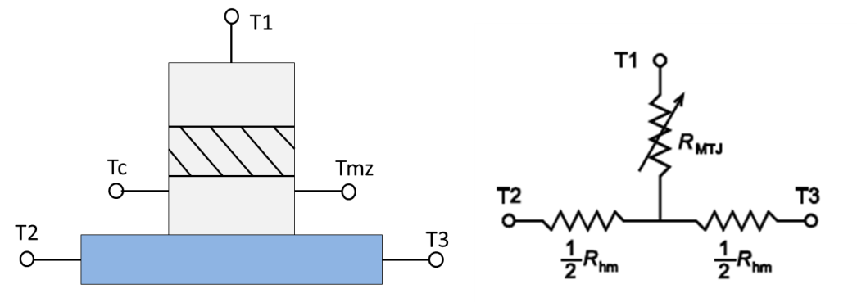

Fig.2.The symbol of PMA_SOT_STT_MTJ

This symbol contains five pins:

A virtual output pin “Tmz” is used to test the state of MTJ. Its output must be one of the two discrete voltage-levels: level ‘0’ indicates the parallel state; level ‘1’ indicates the anti-parallel state.

A virtual output pin “Tc” is used to detect voltage and current value at intermediate points of heavy metal.

Another three pins “T1, T2 and T3” are the real pins. SOT can be generated by Spin-Hall Effect (SHE) current which is applied between T2 and T3. Conventional STT current can be applied between T1 and T2 (T3).

The second file named “**PMA_SOT_STT_DEV**” adds process variation options based on the first model. In this folder, there is a sub file named “seedin.scs” which must be included as a “Global Model File” when a simulation is executed;

Another file named “**PMA_SOT_STT_TB**” is a simple test simulation case using this model in order to demonstrate how it works. The schematic of the test simulation is shown in Fig.3.



Fig.3.Schematic of the Test Bench

We apply two simple current pulses (ipwl1 and ipwl2) as input to generate ISHE and ISTT respectively. ISHE can generate SOT effect regardless of its direction. ISTT should be a bi-direction current which can switch the state of SOT-MTJ. T3 is connected to a 0V vdc and can also be directly grounded.

Because SOT-MTJ is a three-terminal device, we recommend use current source here for better control.

Transient simulation results are as follow:

A. If the SHE write current density is smaller than the critical value, the magnetization will have a disturbance but don’t switching. The disturbance will become stronger with the SHE current increasing.



Fig.4.Only SHE current applied

B. It is worth noting that this model can switch using either a direct STT or a SOT-assisted STT. The SOT-assisted method can eliminate the incubation delay of traditional STT. You can further reduce the STT current density in Figure 5(d), but the switching speed will slow down correspondingly, and even then it will be faster than only STT.

Please refer to “Perpendicular-anisotropy magnetic tunnel junction switched by spin-Hall-assisted spin-transfer torque” [3] for more details.



Fig.5. Simulation results of SOT switching mechanism. (a) The STT current density is 4.31MA/cm2. (b) The STT current density is 4.31MA/cm2 and the SOT current density is 8.33MA/cm2. (c) The STT current density is 4.31MA/cm2 and the SOT current density is 17.6MA/cm2. (d) The STT current density is 2.45MA/cm2 and a 17.6MA/cm2 SOT current is removed at a right time.

**III. Parameters**

**III-A Component Description Format (CDF)**

In order to describe the parameters and the attributes of the parameters of individual component and libraries of component, we use the Component Description Format (CDF). It facilitates the application independent on cell views, and provides a Graphical User Interface (the Edit Component CDF form) for entering and editing component information.

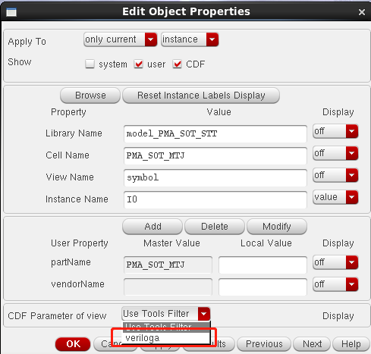

Fig.6.Modify the CDF option

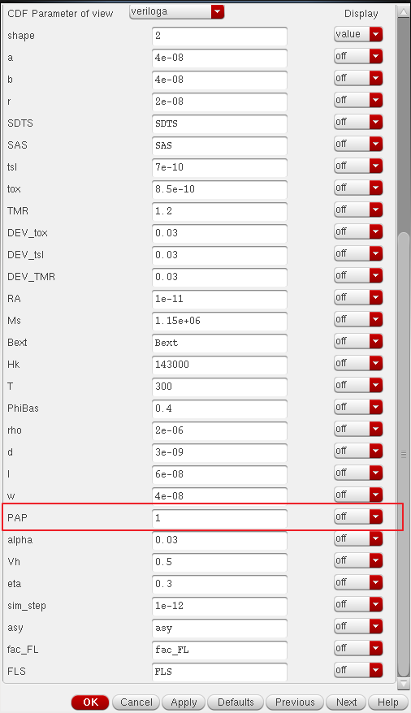

Fig.6. Parameter setting interface

Thanks to its favorable features, we use CDF to define the initial state of PMA MTJ. By entering “0” or “1” in the column “PAP” in category “Property”, we can modify the initial state to parallel or antiparallel (see Fig.6). Furthermore, using CDF tools we can modify multi MTJs’ states individually, which facilitates implementation of more complex hybrid CMOS/MTJ circuits.

**III-B Technology Parameters**

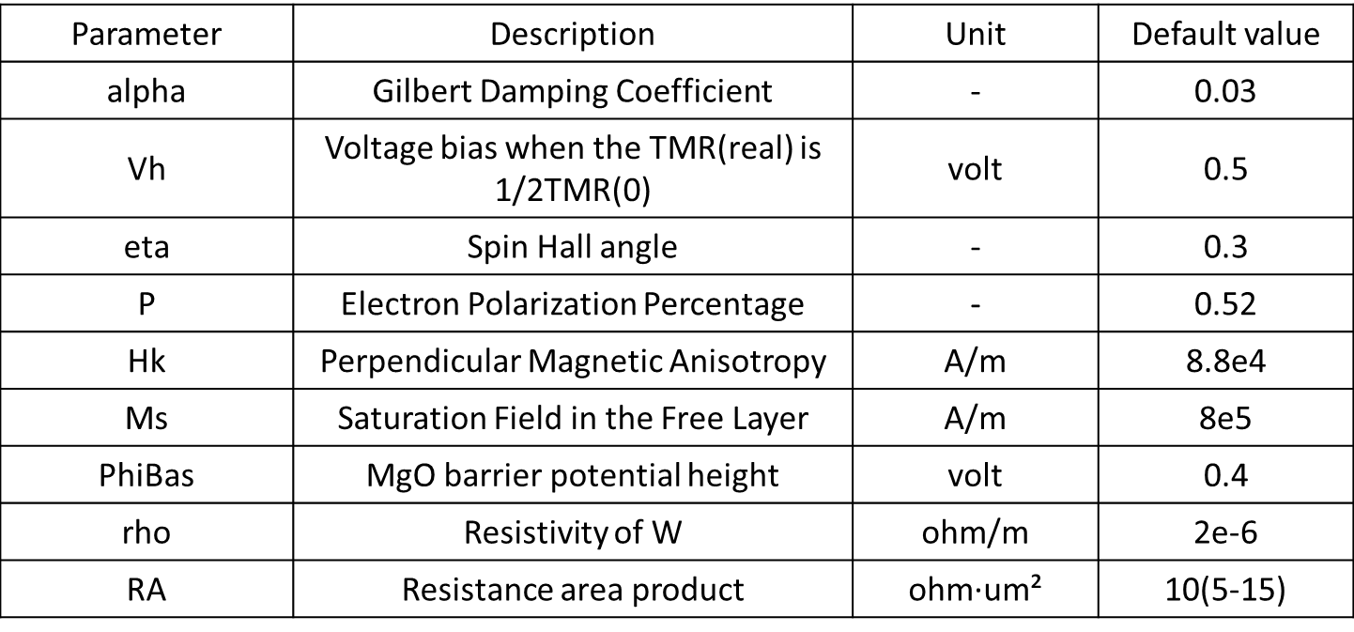

Fig.7. Technology Parameters

These technology parameters depend mainly on the material composition of the SOT-MTJ nanopillar and it is recommended to keep their default value. Of course, if you have better understanding in the MTJ and its parameters, you can modify them according to special needs. (For example, P can be changed and calculated by TMR.)

**III-C Device Parameters**

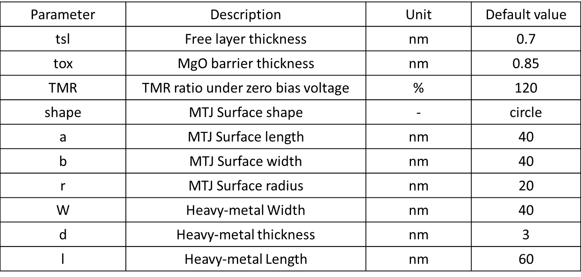

Fig.8. Device Parameters

These device parameters depend mainly on the process and mask design and the designers can change them to adapt their requirements.

The default shape of MTJ nanopillar surface is circular (using r only), but we can use also ellipse or rectangle for specific simulation purposes.

**IV. Function Option**

**IV-A Process variation**

Beyond the SOT-assisted STT behaviors, the second model “**PMA_SOT_MTJ_DEV**” adds process variation options. As the limit of the manufacturing technology, the actual thickness of oxide layer and free layer cannot be fixed at one constant value that we expected. They always vary in a somewhat small range, but can lead to a relatively important variation for MTJ resistance. In addition, we also take the TMR ratio variation into account. The variations for these three parameters are ± 1% (see Fig.9).

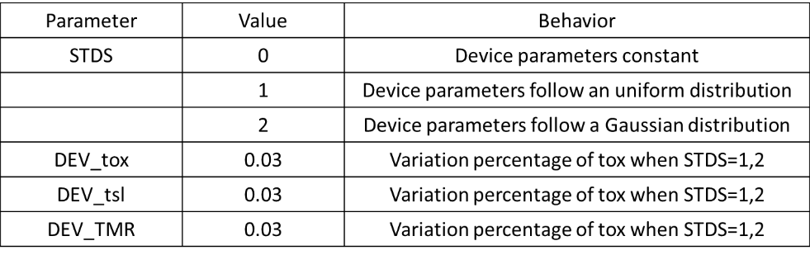

Fig.9 Device variation setting



Fig.10 200 times Monte Carlo results

**IV-B Asymmetry of the STT**

CDF parameter “SAS” can be used to control whether STT asymmetry is considered:

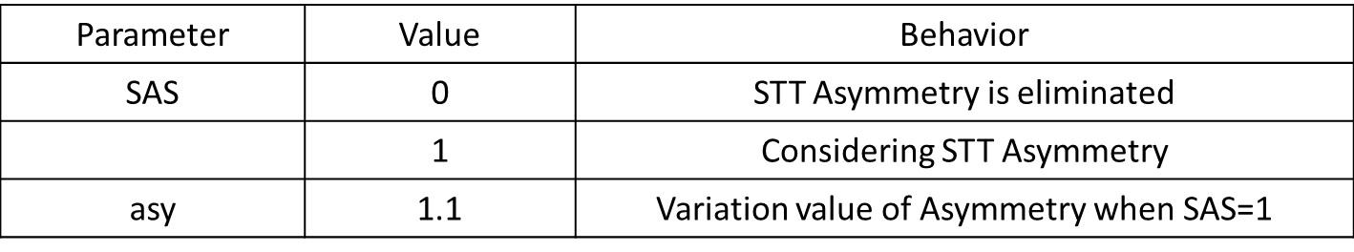

Fig.11 STT Asymmetry Selection

We all know that STT currents aren’t symmetric (AP state is harder to write). In this model, we use the parameter “asy” to calculate this kind of asymmetry. It is important to note that the “asy” values and asymmetry are not linear relationship, which can be seen in veriloga source code. The asymmetry is eliminated when asy=1.

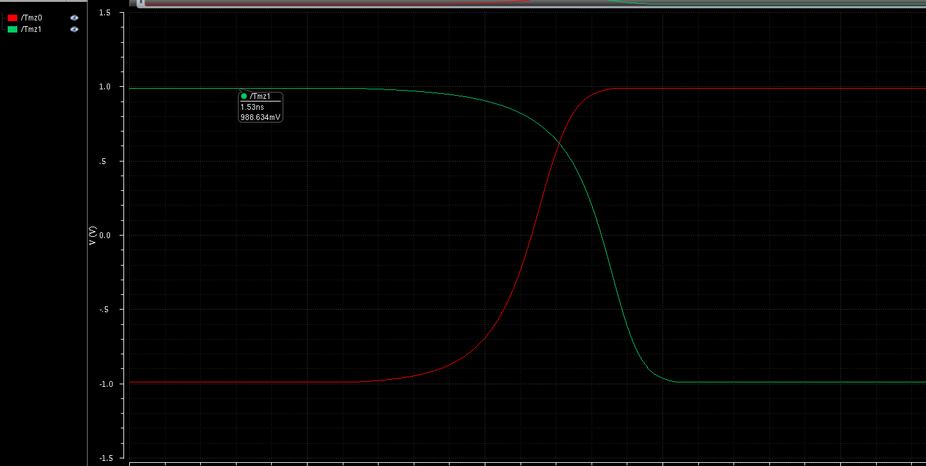

Fig.12 STT Asymmetric simulation results when asy=1.1

**IV-C Field-like Torque**

CDF parameter “FLS” can be used to control whether Field-like is considered. The parameter “Fac_FL” can fluctuate in a large range.

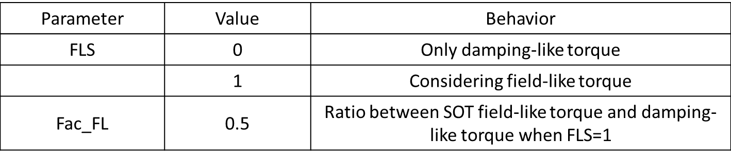

Fig.13 Field-like torque Selection



Fig.14 Transient simulation of Field-like switching when fac_FL=3.5

**IV-D The external magnetic field**

The torque induced by the external magnetic field or exchange bias can be described by a modified Landau-Lifshitz-Gilbert (LLG) equation. As shown in figure below, you can add external magnetic field size as required. The default “Bext” value is -0.005T.

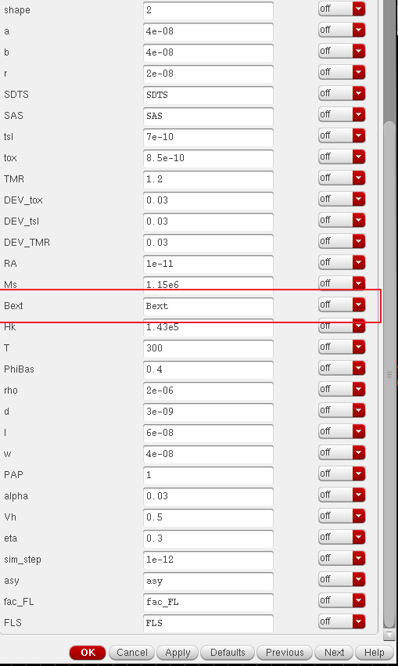

Fig.15 The external magnetic field setting

If you want to run simulation purely electrical, please set it to 0.

**V. Before simulation**

1. When you launch ADE L for a new simulation under Cadence, check if you have added “veriloga ahdl” in the “switch view list” from “Setup”. Otherwise the netlist file may not be generated

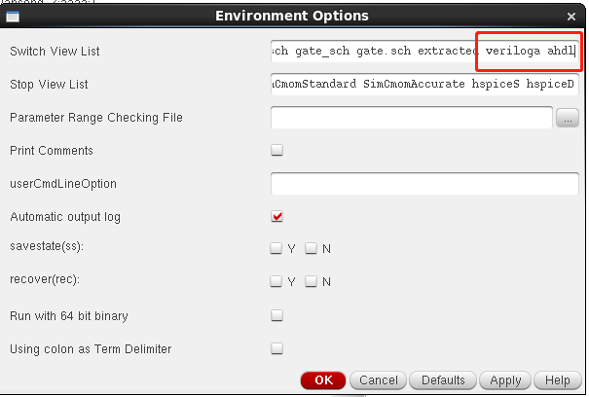

Fig.16 Environment setting

2. Check if you have added “seedin.scs” in the “Setup”.

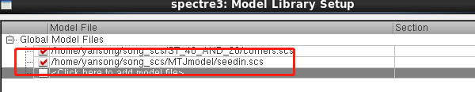

Fig.17Setup setting

It’s necessary when you use “PMA_SOT_STT_DEV” model.

**VI. Other guide**

1. The model does not support dc analysis at present.

2. In 28nm design kit, there may be some bugs. One is if T3 is connected to ground directly, simulation may encounter error. This bug can be solved by connecting a 0V vdc instead (see Fig.18).

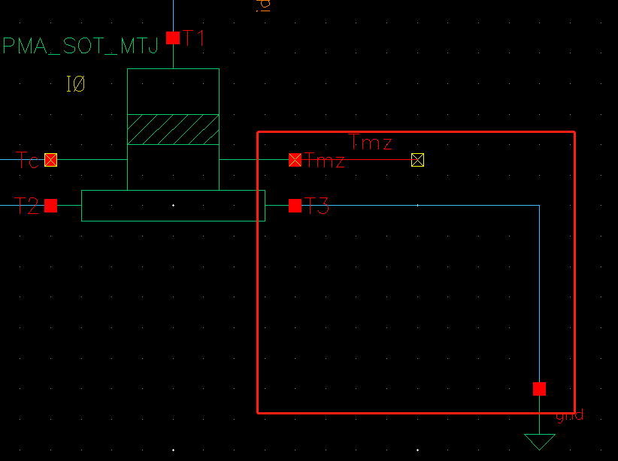

Fig.18 In 28nm design kit

3. This model can be extended to form a new NAND-SPIN memory with flash-like write operation for high-density non-volatile memory applications. [5]

4. More details of simulation can be carried out as shown below.

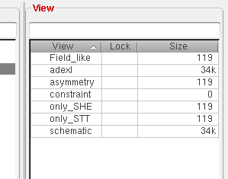

Fig.19 Spectre simulation states

5. We will add more behavior descriptions and update this model on the download site later. If you still have difficulties in using or suggestions for improvement, please contact us.

**VII. Reference**

[1]Wang M, Cai W, Zhu D, et al. Field-free switching of a perpendicular magnetic tunnel junction through the interplay of spin–orbit and spin-transfer torques [J]. Nature Electronics, 2018, 1(11): 582-8.

[2]Zhaohao Wang. Compact modeling and circuit design based on ferroelectric tunnel junction and spin-Hall-assisted spin-transfer torque. Micro and nanotechnologies/Microelectronics. Uni-versité Paris-Saclay, 2015. English. <NNT : 2015SACLS036>. <tel-01231506>

[3]Wang Z, Zhou H, Wang M, et al. Proposal of Toggle Spin Torques Magnetic RAM for Ultrafast Computing[J]. IEEE Electron Device Letters, 2019, 1.

[4]Wang Z, Zhao W, Deng E, et al. Perpendicular-anisotropy magnetic tunnel junction switched by spin-Hall-assisted spin-transfer torque[J]. Journal of Physics D: Applied Physics, 2015, 48(6): 065001.

[5]Wang Z, Zhang L, Wang M, et al. High-Density NAND-Like Spin Transfer Torque Memory With Spin Orbit Torque Erase Operation[J]. IEEE Electron Device Letters, 2018, 39(3): 343-6.